**Raspberry Pi 4 – PIN DIAGRAM**

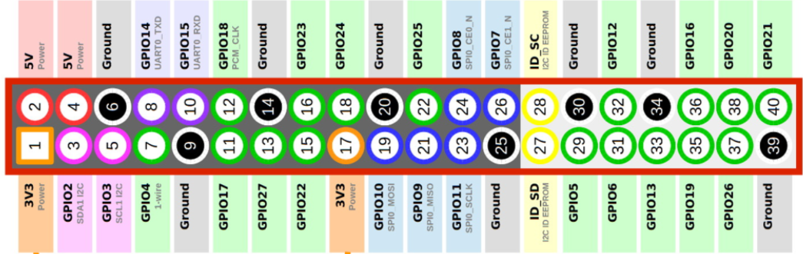

1

2

3

4

5

6

7

8

9

10

11

12

13

14

15

16

17

18

19

20

11

10

9

8

7

6

5

4

3

2

1

12

13

14

15

16

17

18

19

20

**Raspb**

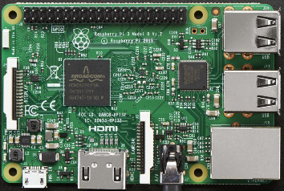

**GPIO14 / PIN 14**

**GPIO5 / PIN 5**

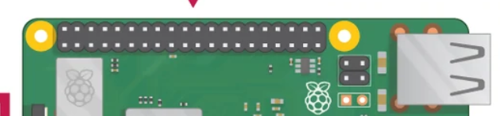

**THE NUMBER IN BLUE COLOURED CIRCLES ARE MEANT TO HELP YOU IDENTIFY THE GPIO PIN LOCATION ON YOUR RASPBERRY PI. FOR EXAMPLE, GPIO23. IT IS THE NO 8 PIN FROM THE LEFT. SAVE YOU THE TROUBLE OF COUNTING.**